PF Lab Assignment

# Problem 1:

Which loop system would be better for user input. Justify your answer by creating a program that takes a value and adds it to a variable and prints it repeatedly until the user enters a zero value.

### Source code:

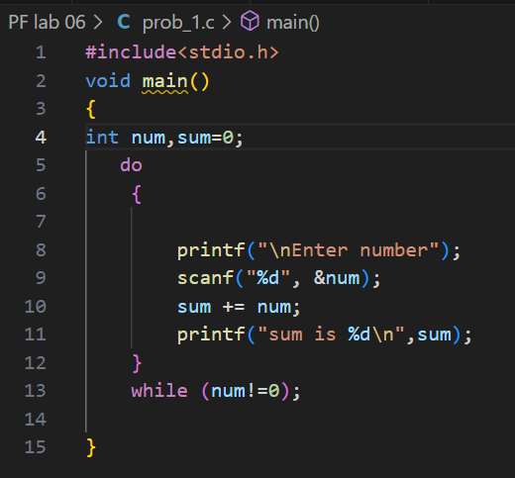

### Output:

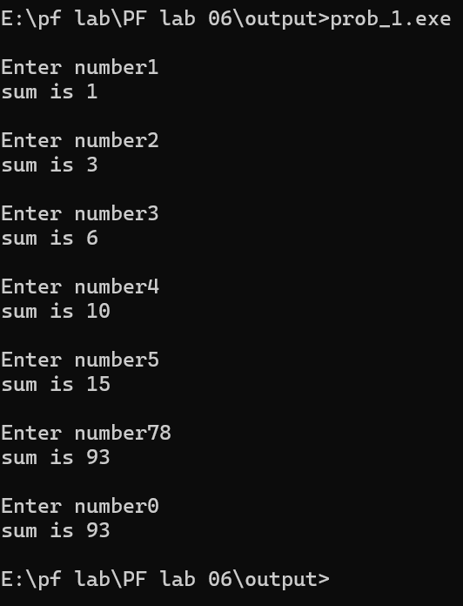

# Problem 2:

Write a program to check whether a given number is a multiple digit number or not.

1. Example: 123 is a multiple digit number.

2. 6 is not a multiple digit number.

### Source code:

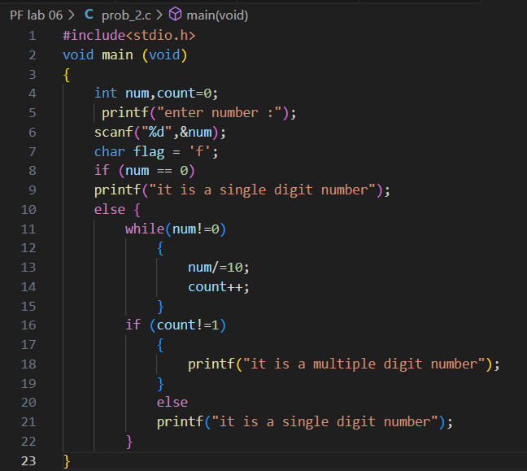

### **Output:**

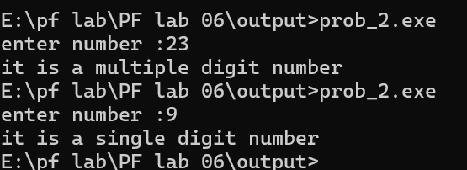

# Problem 3:

Using the above program integrate the number if it is a prime or composite number.

### Source code:

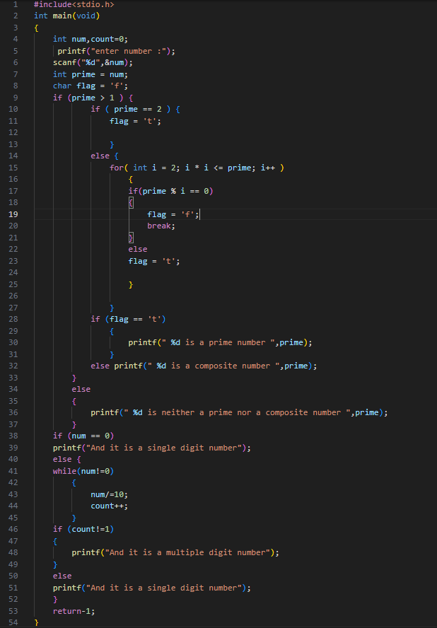

### Output:

# 

# Problem 4:

Write a program to print the following series: 1, 2, 3, 5, 8, 13.

### Source code:

### 

### Output:

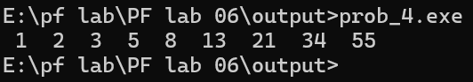

# Problem 5:

Using for-loop statement print the following series:



### Source code:

### 

### Output:

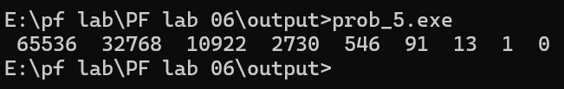

# Problem 6:

Create a C program to calculate the following series using loop statements.

### Source code:

### 

### Output:

